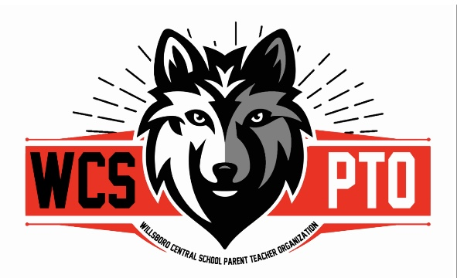

Agenda for Tuesday, June 10th @ 4:30pm
at the Willsboro Central School Distance Learning Room

Join Zoom Meeting
https://plattsburgh.zoom.us/j/86007071002
Meeting ID: 860 0707 1002
• +1 646 931 3860 US

- Call the meeting to order :

- Attendance:

- Accept the minutes:

- Update from Treasurer:

- Housekeeping from last meeting:
- 1023-EZ form submitted on 5/26/25 waiting for approval to become a 501(3)(c)
- Form to Ms. Paquette with letter to staff?

- Fundraisers and Events:
  - “Sweet Treat” event, tickets handed out to all WCS students & Flyer on Parent Square (6/11)
  - Fundraiser: Color Run– July 19th @ the Indian Bay Marina
  - Event: Open House for 2025/26 School Year – date/plan (8/28/25)
    - Need a volunteer to apply for donation for Stewart’s “Make your own Sundae kit”
  - Event/Fundraiser: Fall Festival – date/plan
  - Fundraiser: Bowling Tournament – date/plan

- Discussion:

- Nomination of WCS PTO Officers:
  - Vote
  - Do by-laws need updating?

- Next meeting:

- Adjourn:

